Result Sheet Template is incorrect or not Aligning

Issue
The Result Sheet is the incorrect version; or the printed metrics are not aligned into the boxes
- Check to ensure that the Result Sheet they are printing on Matches the correct version shown on their Control Panel:
  - If the Print Template is incorrect; the insights team or EVOLT Team will need to update the customer profile to the correct version Result Sheet they are using

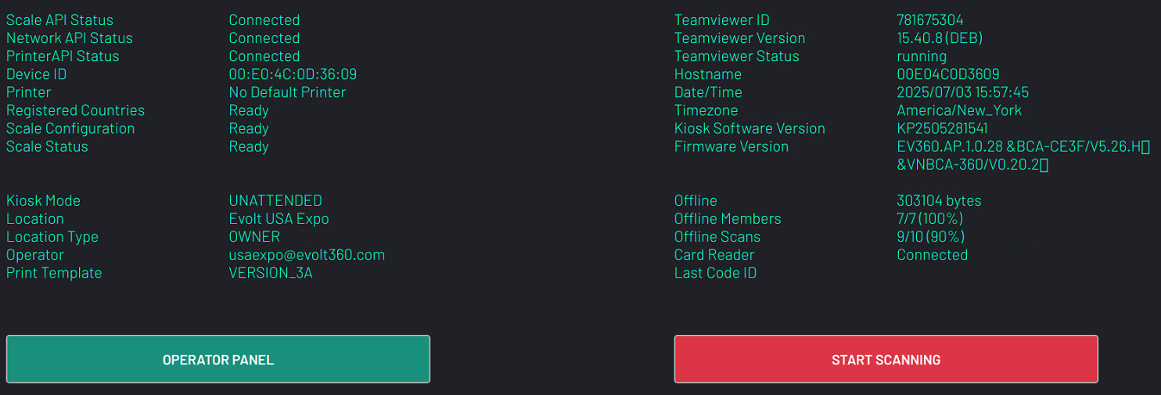

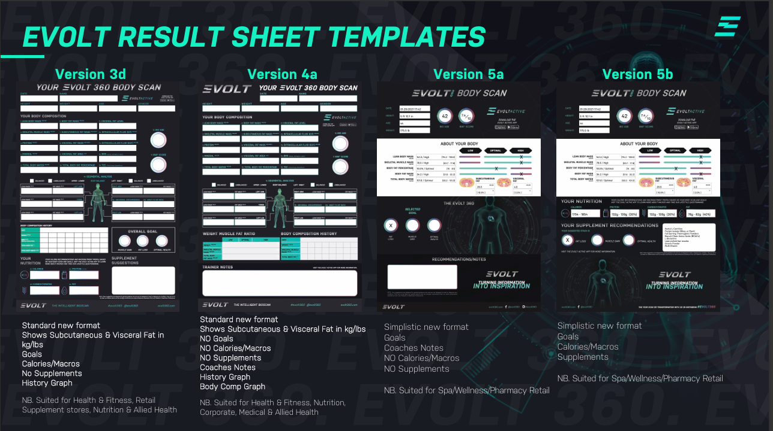
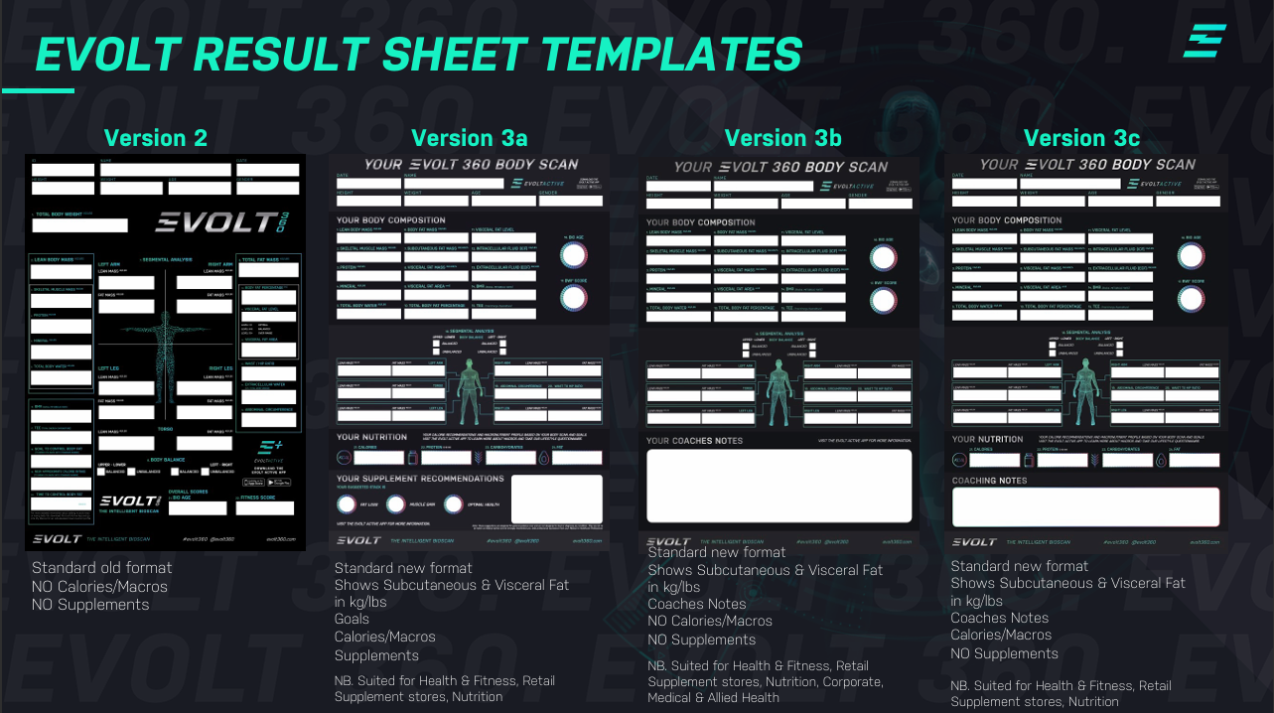
Different Template options we offer
- If the Template Version on the Kisok is correct to the type of Sheet that they are using; ensure that they have the paper properly fit inside of the tray of the printer and the tabs are tight to the sheet.
- Check that in the printer settings on the Kisok; it is sized correctly, whether it is US Letter of A4 sized paper.
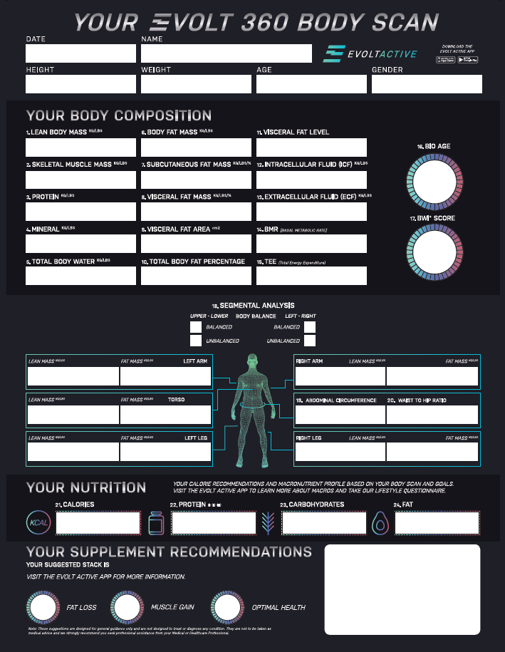
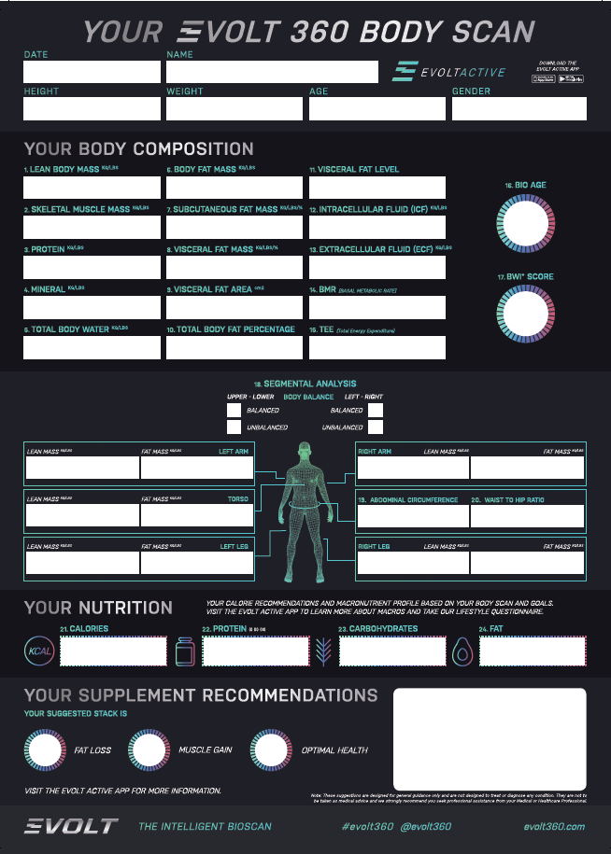
  - An easy way to tell on the size of the paper is if the Black bar is on the bottom of the Result Sheet; if it is then it is printed on A4.

A4 Artwork US Letter Arwork

- If you need to change the paper size in the Printer Settings
  - Select the printers option from the Control Panel and select the Printer being used
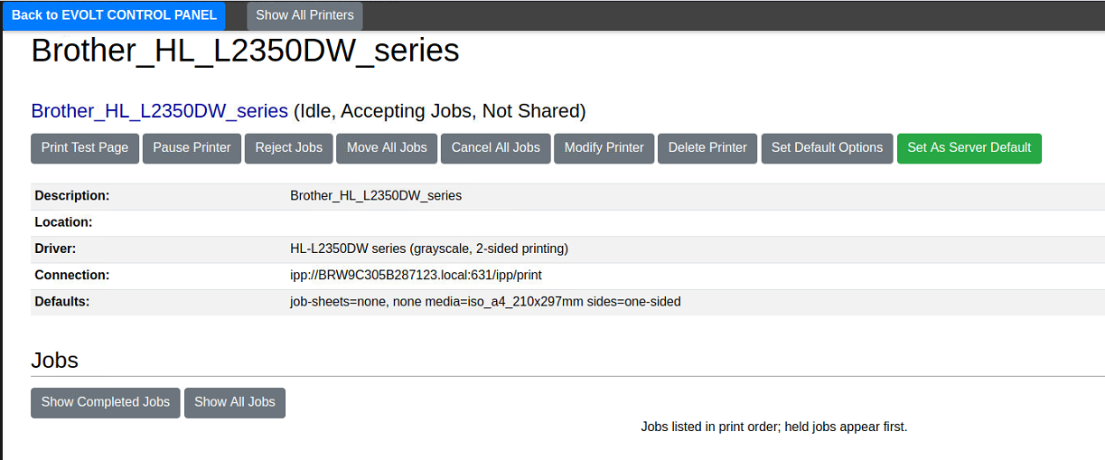
  - Select “Set Default Options”
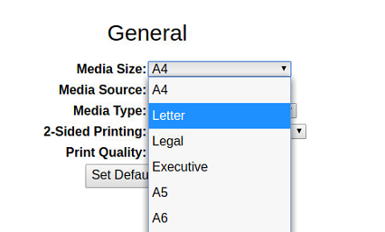
  - Chose the appropriate “Media Size”; either A4 or Letter
- Run a test print to check for the print to be aligned correctly

